Exp. 11: Geometrical Optics

Josiah Schmitz

Kira Leslie

Thomas McGraw

Daniel Sweeney

Physics 2410 Lab

30 November 2023

Abstract

The purpose of this experiment was to analyze the effects of various types of lenses on incoming light. This was done by setting up different configurations of lenses and allowing light to pass through, then measuring the image distance and focal length for various object distances. The measured focal lengths for the 10 and 20 cm converging lenses were 9.84 and 19.95 cm, respectively. The calculated focal length for the 15 cm diverging lens was 14.83 cm.

Introduction

When light passes through a material with a different index of refraction than air, the material will refract the light at some angle different from its original angle. This phenomenon can be represented using Snell’s Law, which states that $n_{1}sinθ_{1}=n_{2}sinθ_{2}$, where $n_{1}$ and $n_{2}$ are the different indexes of refraction, and $θ_{1}$ and $θ_{2}$ are the two angles of incidence. By using this formula to calculate the index of refraction of a material, the speed of light in a vacuum (3e8 m/s) can be divided by this index of refraction to determine the speed of light in this material.

There are two major types of lenses that are commonly used to refract light: converging and diverging lenses. As the names imply, converging lenses converge light at a specific point known as the focal point in front of the lens. The focal length, *f*, of the lens refers to the distance between the lens and the focal point. Additionally, if an object is placed behind the lens at an object distance, *o*, the converging light will project an image of the object at an image distance, *i*, some distance in front of the lens. Divergent lenses work opposite to converging lens, where they instead diverge the light exiting in front of the lens. However, when the diverging rays are traced backwards behind the lens, they form a virtual image. Because of this, the focal and image distances for a diverging lens are negative. For both converging and diverging lenses, the object, image, and focal distances of the lenses are related in the thin lens formula $\frac{1}{o}+\frac{1}{i}=\frac{1}{f}$.

Procedure

For the first part of the experiment, a glass block was placed on top of a cork board with a light shining through it. Pins were then placed along the path of the light before entering and after exiting the glass block, and lines were drawn along the path of the pins. The block was then removed from the cork board, and a line was drawn to connect the ends of the light’s paths. A protractor was then used to measure the two angles of incidence and the two angles of refraction. The average of each pair of angles was then taken. Using Snell’s Law, the index of refraction for the glass block could be calculated, as well as the speed of light in the glass block.

For the second part, a converging lens with a 10 cm focal length was set on a track with an object distance of 27 cm and a light shining a particular image into the lens. A screen was in front of the lens and was adjusted until the image projected onto it through the lens was at its visible sharpest. The image distance was then measured and used along with the object distance to calculate the focal length of the lens and its magnification. The object distance was then changed to 17 and 7 cm and the test was repeated each time.

The third part of the experiment was nearly identical to the second part. This time, however, a 20 cm converging lens was used, and the object distances used were 47, 27, and 17 cm.

For the fourth part of the experiment, a diverging lens with a -15 cm focal length was used. Because a diverging lens was used, no image was projected on the screen. Instead, the diameter of the physical stop holding the lens was measured, along with the length of the vertical line on the screen. The screen was then moved to a point at which the circle of light exiting the diverging lens had approximately the same diameter as the length of the vertical line. The focal length of the lens could then be calculated by dividing the product of the stop’s diameter and the distance between the lens and screen by the difference between the vertical line’s length and the stop’s diameter.

For the fifth part, the 10 cm converging lens was set up 25 cm away from the light source, and the -15 cm diverging lens was set up 35 cm away from the light source on the track. The screen was then moved until the light exiting the diverging lens produced the sharpest image, and this image distance was measured.

Results

Part 1: The calculated index of refraction of the glass block was 1.53. Meanwhile, the handbook value of the index of refraction of glass is 1.5. The percent difference was only 2.113%, showing that the index of refraction was calculated accurately. Additionally, the speed of light in the glass block was calculated to be 195,900,000 m/s.

Part 2: The average focal length of the 10 cm converging lens was calculated to be 9.84 cm. This is only a 1.56% difference when compared to the manufacturer’s value of 10 cm for the lens’ focal length. Also, the magnifications of the image at object distances of 27, 17, and 7 cm were -0.57, -1.39, and 3.46.

Part 3: The average focal length of the 20 cm converging lens was calculated to be 19.95 cm. This is only a 0.25% difference when compared to the manufacturer’s value of 20 cm for the lens’ focal length. Also, the magnifications of the image at object distances of 47, 27, and 17 cm were -0.74, -2.84, and 6.76.

Part 4: The calculated focal length of the -15 cm diverging lens was calculated to be -14.83 cm. This is only a 1.16% difference compared to the manufacturer’s value of -15 cm for the lens’ focal length.

Part 5: The measured image distance from the diverging lens was 10.60 cm. To calculate the image distance from the diverging lens, the image distance for the 10 cm converging lens was first calculated with the thin lens equation by using the object distance of 25 cm from the light source to the converging lens. 10 cm were then subtracted from the resulting image distance. This resulting number gave us the object distance to be used in the thin lens equation to calculate the image distance from the -15 cm diverging lens. This image distance was calculated to be exactly 12 cm. The percent difference between the measured and calculated image distances was 11.67%.

Questions to be Answered

1. There was a level of random uncertainty due to possible human error when visualizing the line from the light source through the block and when drawing the lines between the pins. There was also systematic uncertainty due to the protractor.
2. There was random uncertainty due to human error when determining at what point the image looked sharpest. There was also systematic uncertainty when measuring the object and image distances on the track.
3. Spherical aberration is when some of the light towards the edge of the lens is refracted so strongly that the edge of the image becomes blurry. Chromatic aberration is when different colors of light are refracted slightly differently from each other due to the index of refraction varying with the wavelengths of visible light.
4. The magnification of the telescope equals the focal length of the objective divided by the focal length of the eyepiece. Therefore, M = 19.95/9.84 = 2.027.

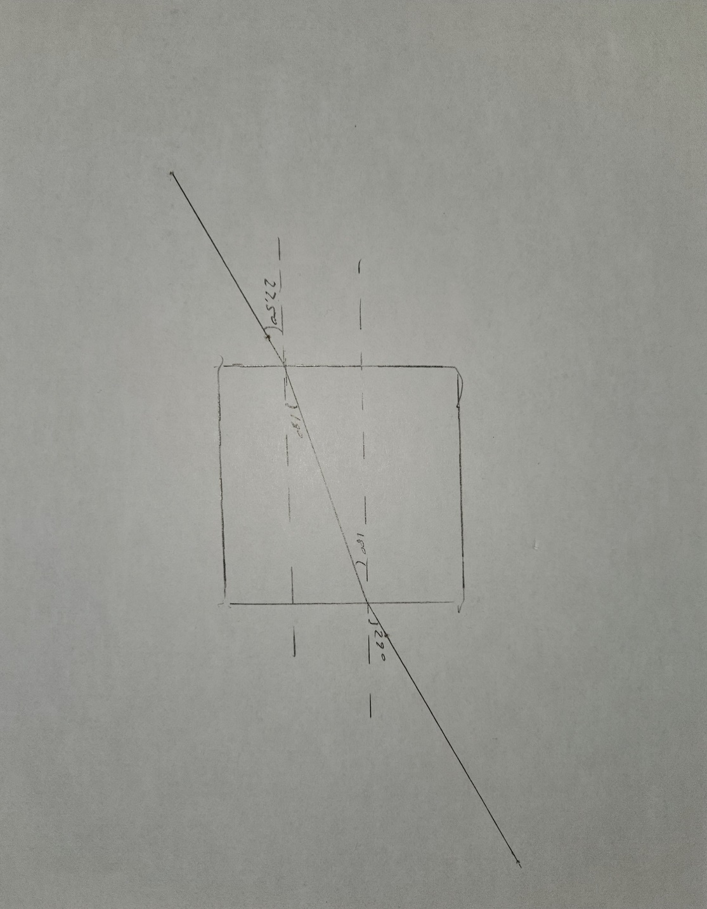

**Ray Diagrams:** (Copy this page and include it in your report. Use the drawing application in Word to draw the rays and the imaged formed. Use a different color of your choice to draw with.)

Obj. > 2f

2f

f

f

IMAGE

2f > Obj. > f

f

f

2f

IMAGE

f > Obj.

f

f

2f

VIRTUAL IMAGE